EXPLORATORY DATA ANALYSIS REPORT PER CANDIDATE



**Name: Vasupally Tarun Dorai Raj**

**Email: Vasupally.dorairaj.21063@iitgoa.ac.in**

Contents

**CANDIDATE 1:** 4

**Analysis of transcripts.txt** 4

**Graphs of emotion.csv** 4

**Graphs of transcripts_data:** 6

**CANDIDATE 2:** 8

**Analysis of transcripts.txt** 8

**Graphs of emotion.csv** 8

**Graphs of transcripts_data:** 10

**Candidate 3:** 12

**Analysis of transcripts.txt** 12

**Graphs of emotion.csv** 12

**Graphs of transcripts_data:** 14

**CANDIDATE 4:** 16

**Analysis of transcripts.txt** 16

**Graphs of emotion.csv** 16

**Graphs of transcripts_data:** 18

**CANDIDATE 5:** 20

**Analysis of transcripts.txt** 20

**Graphs of emotion.csv** 20

**Graphs of transcripts_data:** 22

**CANDIDATE 6:** 24

**Analysis of transcripts.txt** 24

**Graphs of emotion.csv** 24

**Graphs of transcripts_data:** 26

**CANDIDATE 7:** 28

Analysis of transcripts.txt 28

**Graphs of emotion.csv** 28

**Graphs of transcripts_data:** 30

**CANDIDATE 8:** 32

**Analysis of transcripts.txt** 32

**Graphs of emotion.csv** 32

**Graphs of transcripts_data:** 34

**Candidate 9:** 36

**Analysis of transcripts.txt** 36

**Graphs of emotion.csv** 36

**Graphs of transcripts_data:** 38

**CANDIDATE 10:** 40

**Analysis of transcripts.txt** 40

**Graphs of emotion.csv** 40

**Analysis of transcripts_data:** 42

NOTE:

All the detail explanation of the data analysis is explained in the EDA report. This is just to have a brief look on each of the candidate’s overall performance.

# **CANDIDATE 1:**

## **Analysis of transcripts.txt**

(Communication skills)

Jeffrey Shepherd:

Score: 9/10 (communication skills)

Remarks: Jeffrey Shepherd demonstrates strong communication skills and provides a detailed overview of his education, work experience, and personal interests. He emphasizes his ability to set and achieve goals, which adds to his profile positively.

Areas of Expertise: Regulatory affairs in the pharmaceutical industry, medical writing, drug safety, risk management, biotechnology, baking, research, and attention to detail.

## **Graphs of emotion.csv**

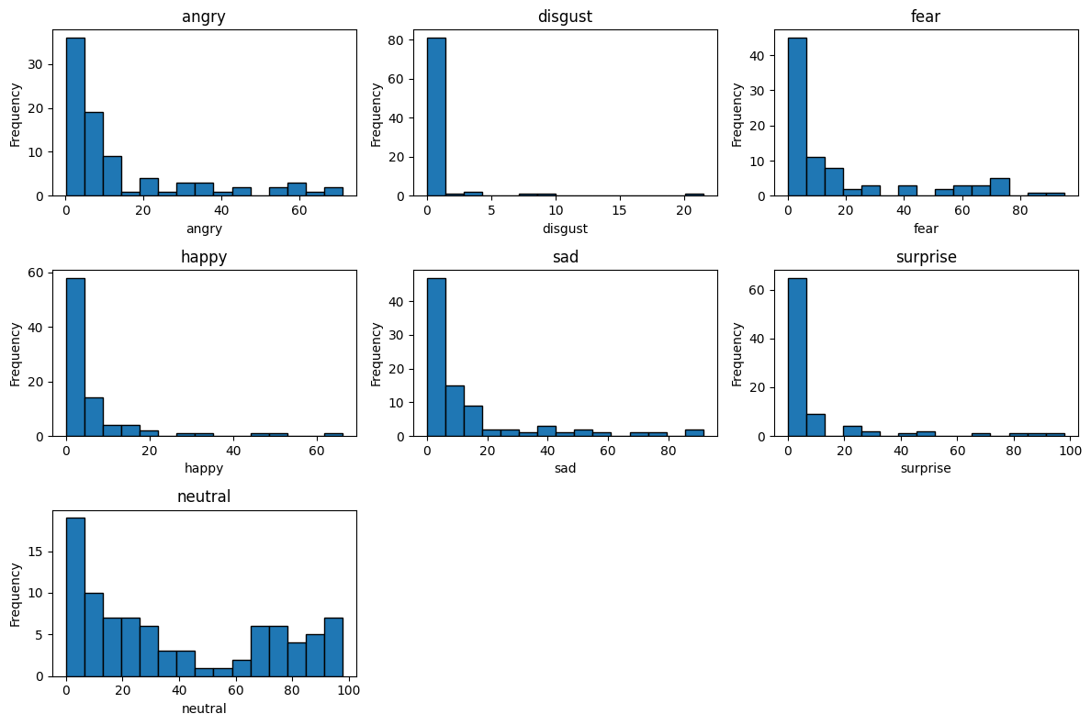

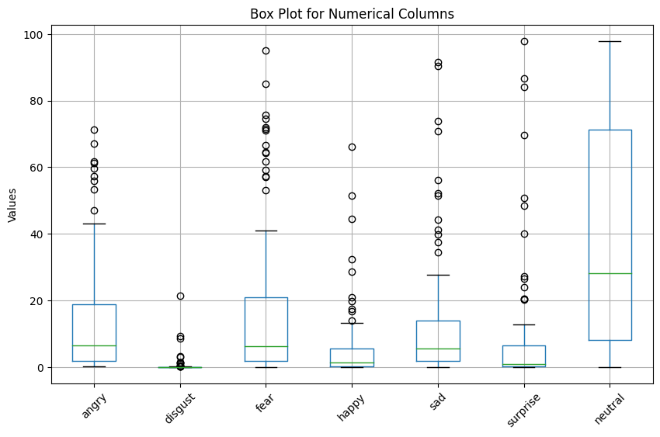

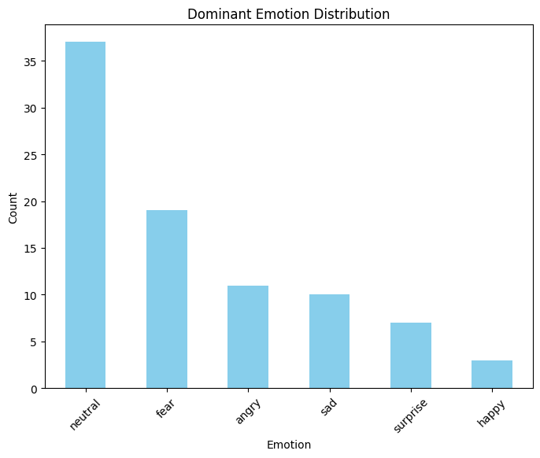

## **Graphs of transcripts_data:**

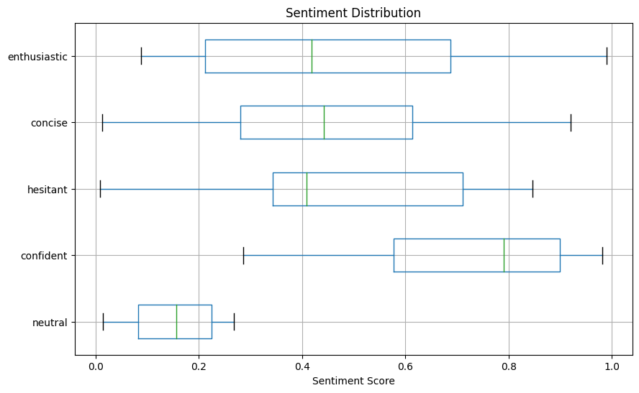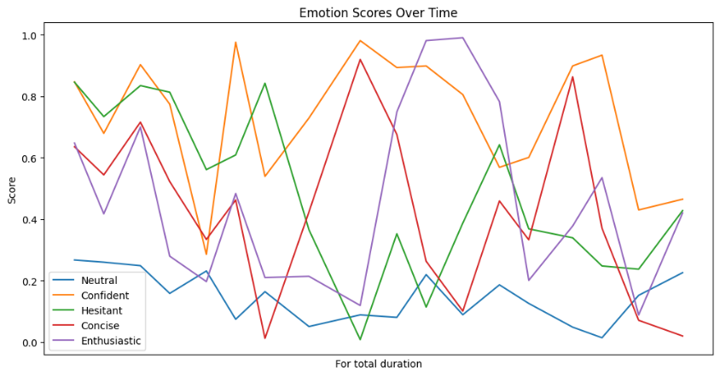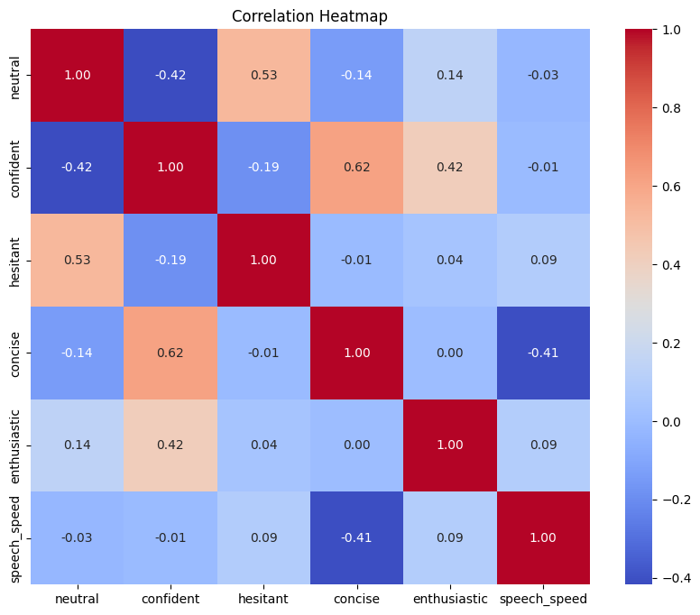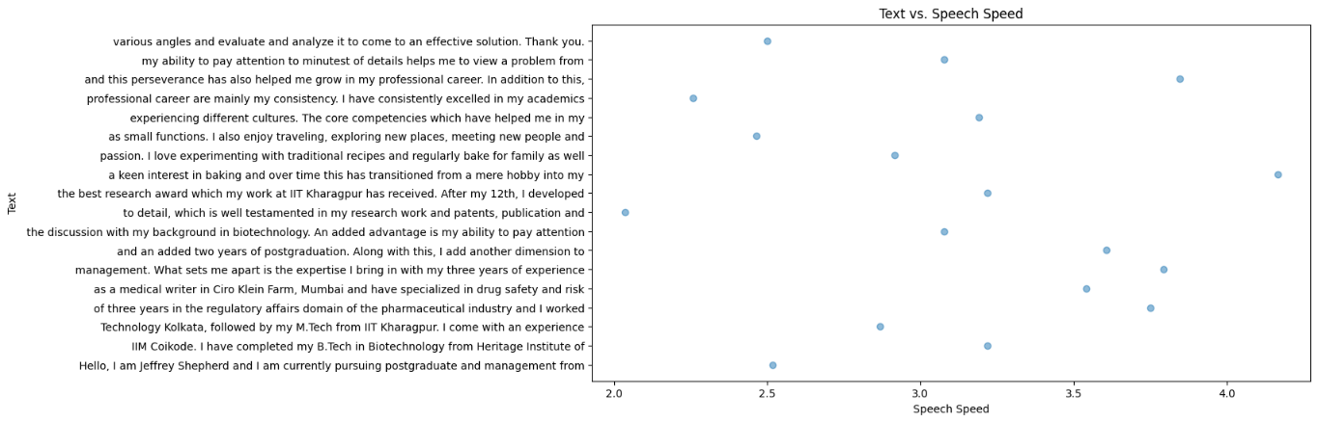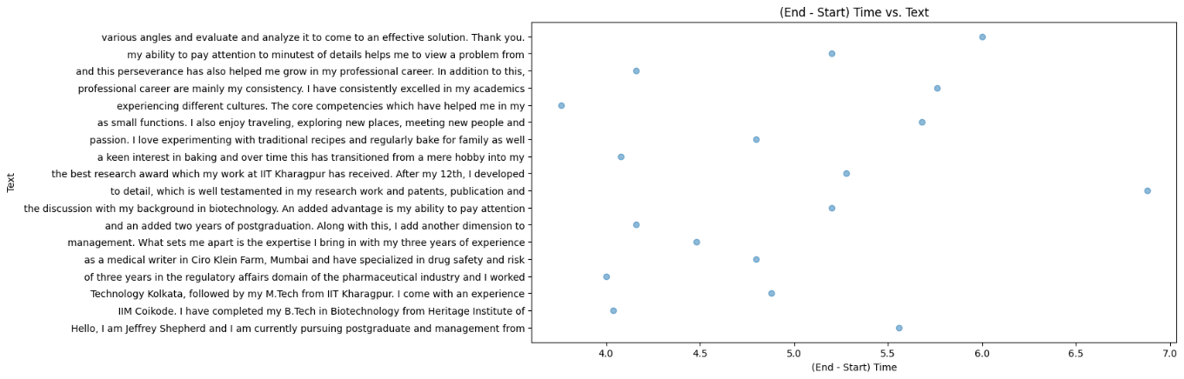

# **CANDIDATE 2:**

## **Analysis of transcripts.txt**

(communication skills)

Cameron Barajas:

Score: 7/10

Remarks: Cameron Barajas presents a concise overview of his qualifications and internship experiences. While he mentions his flexibility and passion, his response could benefit from more specific examples of setting and achieving targets.

Areas of Expertise: Venture network development, startup growth, financial modeling, finance.

## **Graphs of emotion.csv**

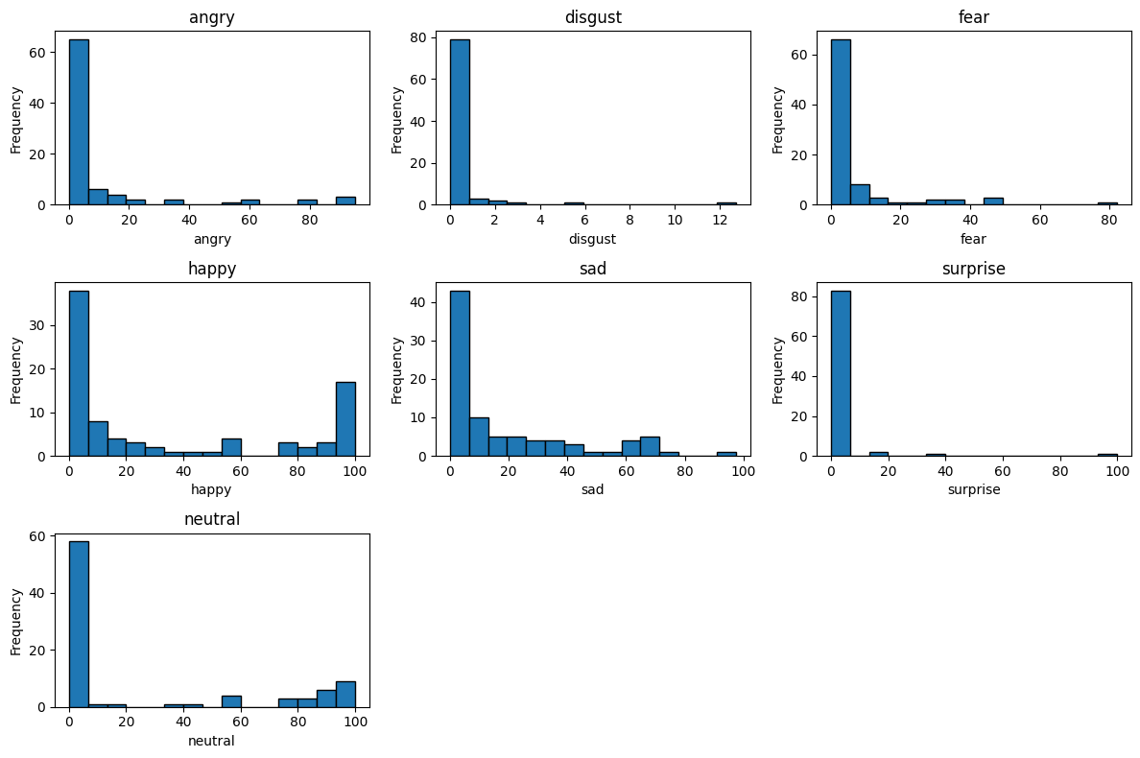

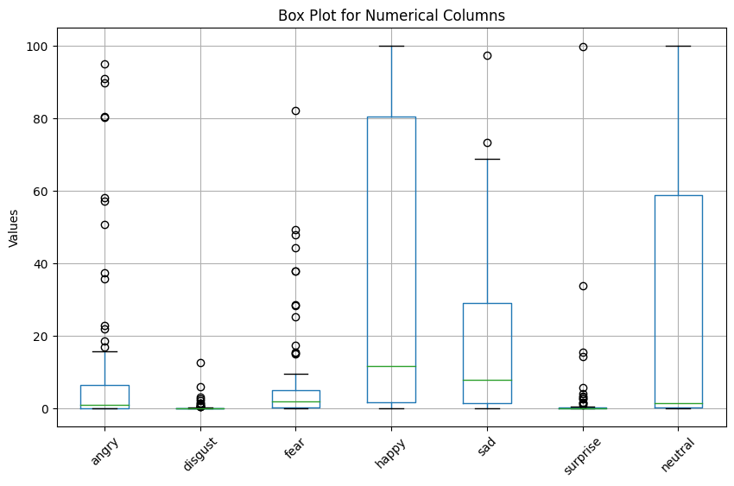

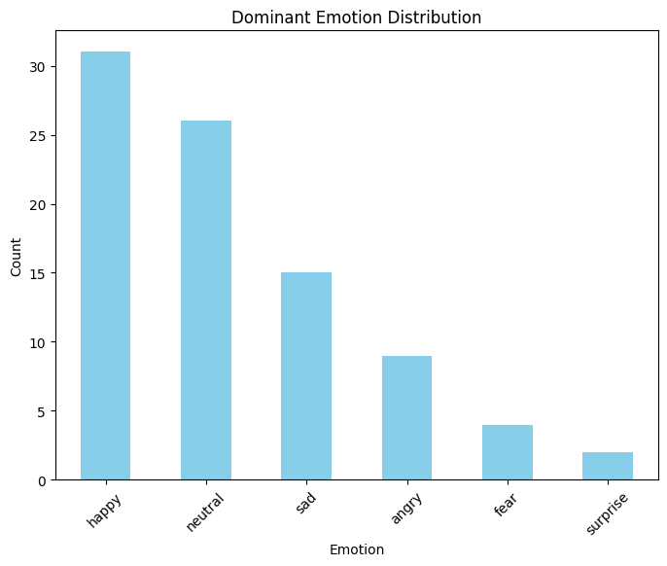

## **Graphs of transcripts_data:**

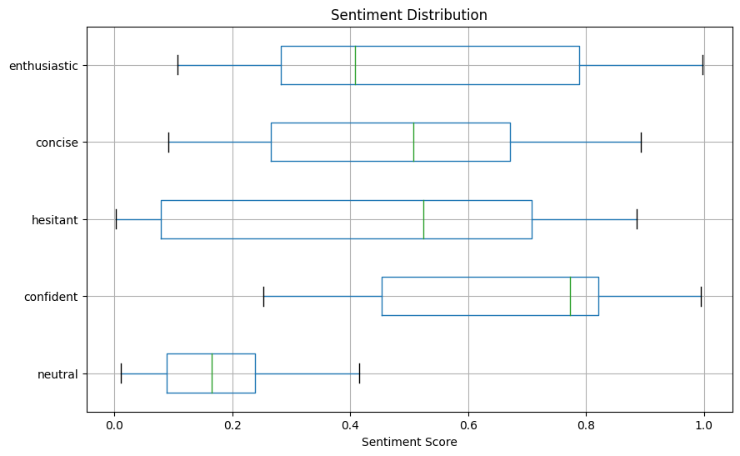

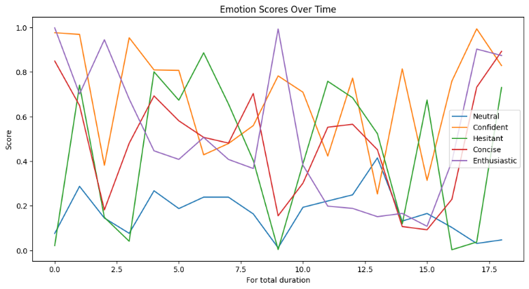

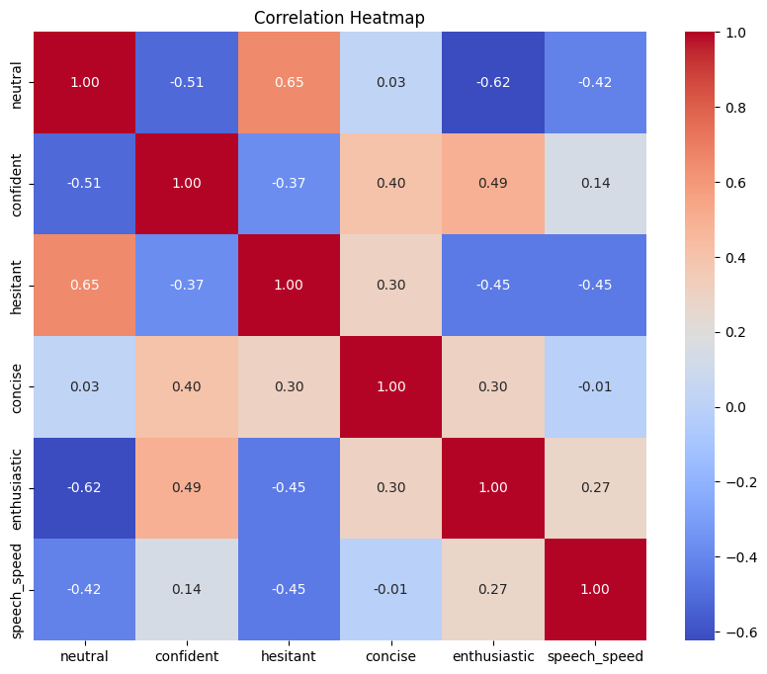

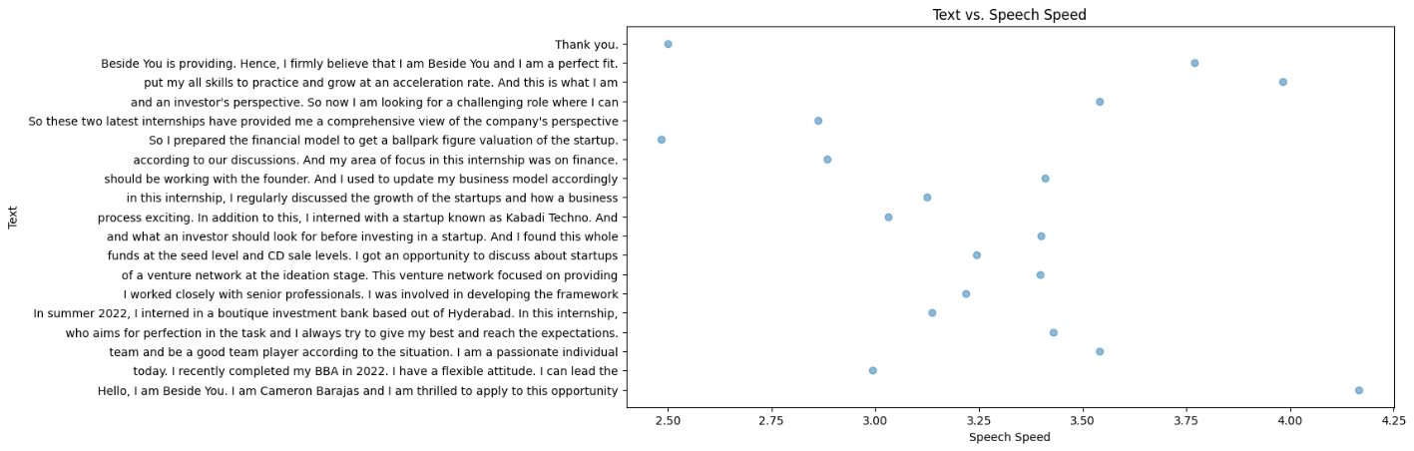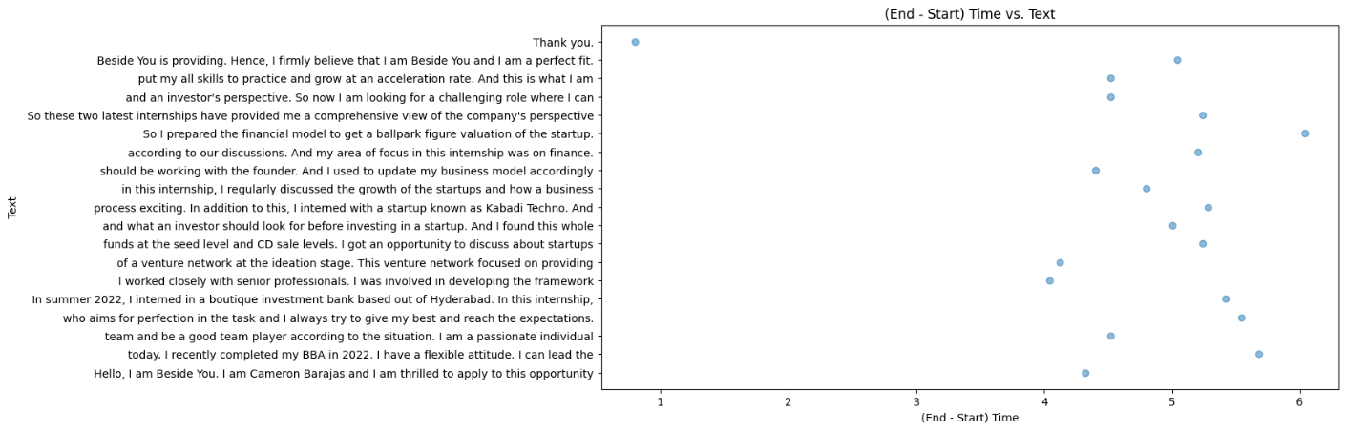

# **CANDIDATE 3:**

## **Analysis of transcripts.txt**

(communication skills)

Michael Guzman:

Score: 6/10

Remarks: Michael Guzman shares his academic and extracurricular background but could improve by providing concrete examples of goal-setting and achievement. His response still lacks a strong connection to the job.

Areas of Expertise: Academic excellence, event organizing, volunteering, sales, accounting, guitar playing, fingerstyle guitar, online content creation.

## **Graphs of emotion.csv**

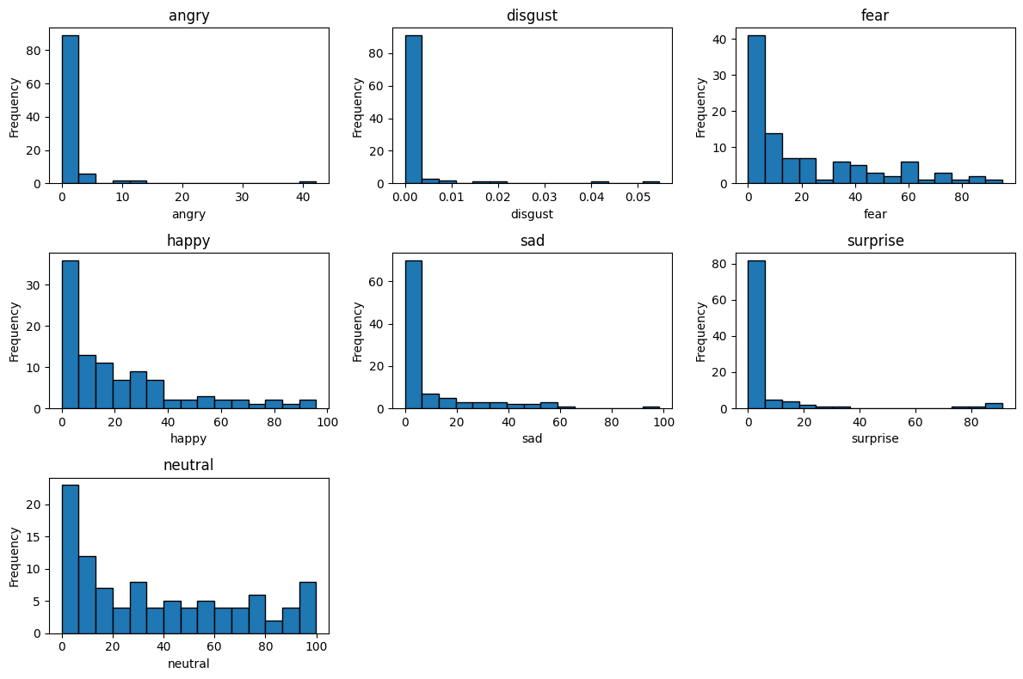

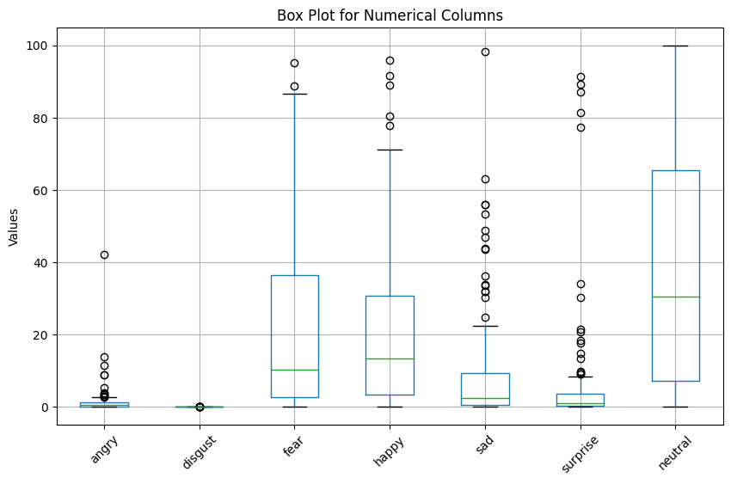

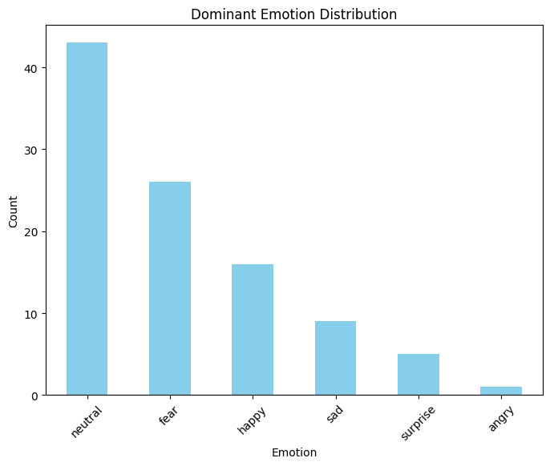

## **Graphs of transcripts_data:**

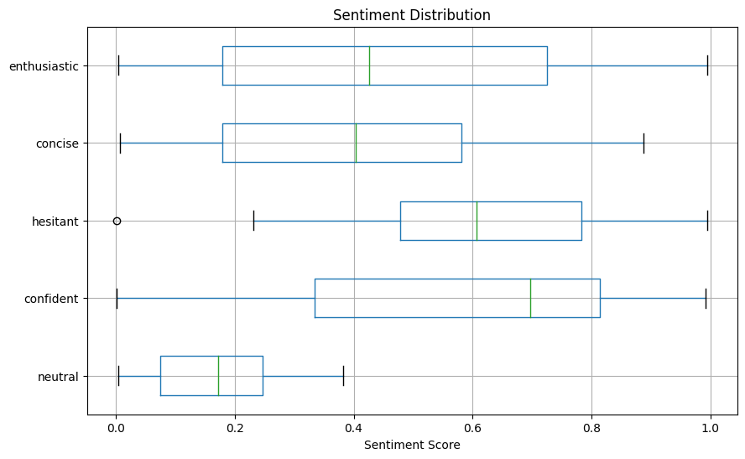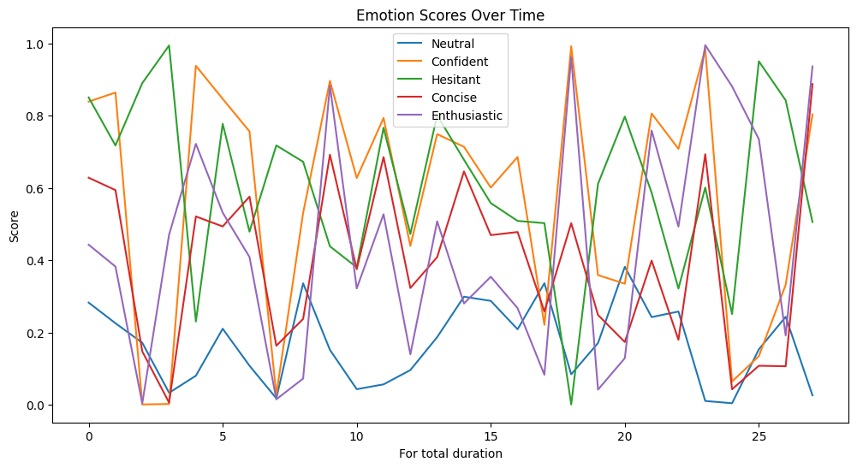

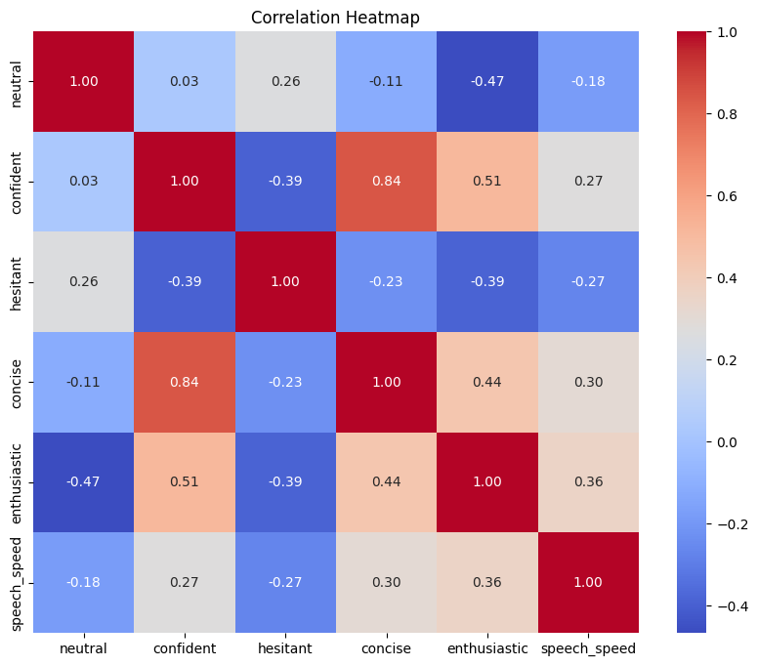

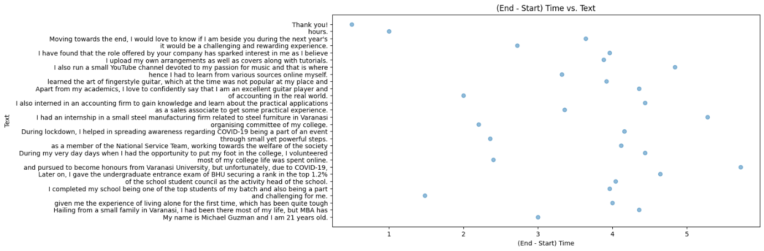

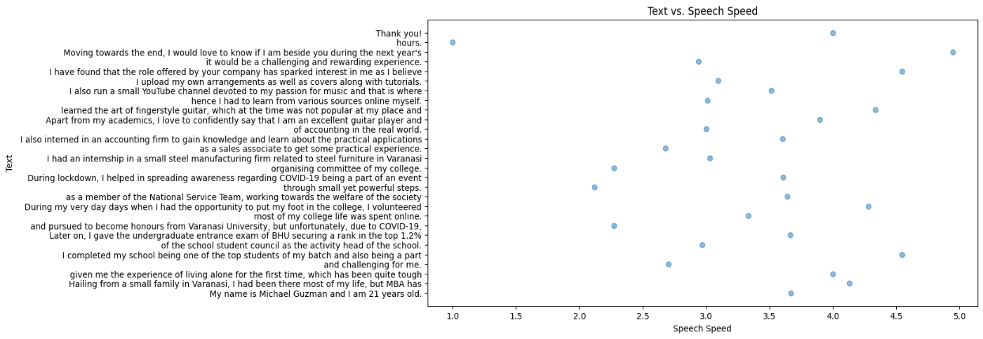

# **CANDIDATE 4:**

## **Analysis of transcripts.txt**

(communication skills)

Monique McCormick:

Score: 8/10

Remarks: Monique effectively highlights her educational background and work experiences. While she mentions her passion for challenges and resilience, more specific examples of setting and exceeding targets would enhance her response.

Areas of Expertise: Electronics and communication engineering, academic advising, auditing, data analysis, machine learning, badminton, chess.

## **Graphs of emotion.csv**

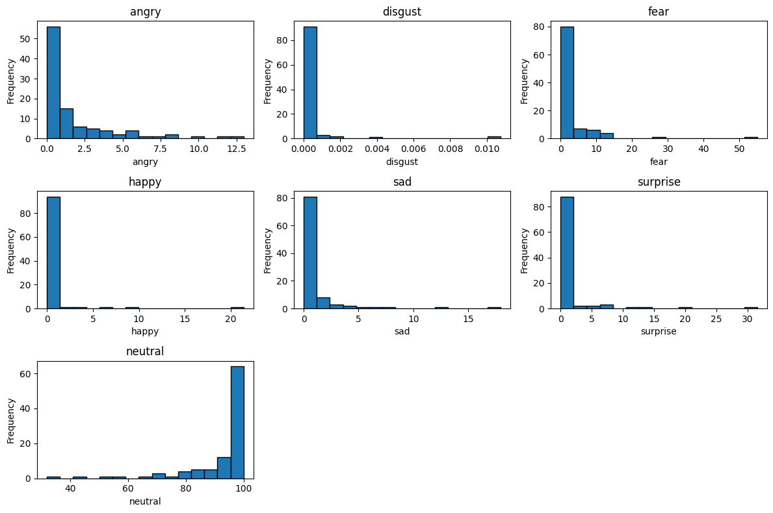

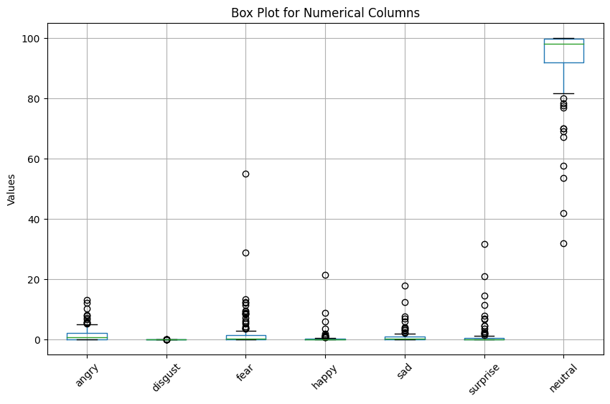

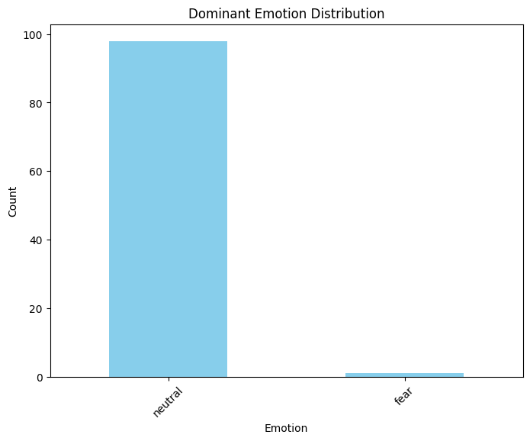

## **Graphs of transcripts_data:**

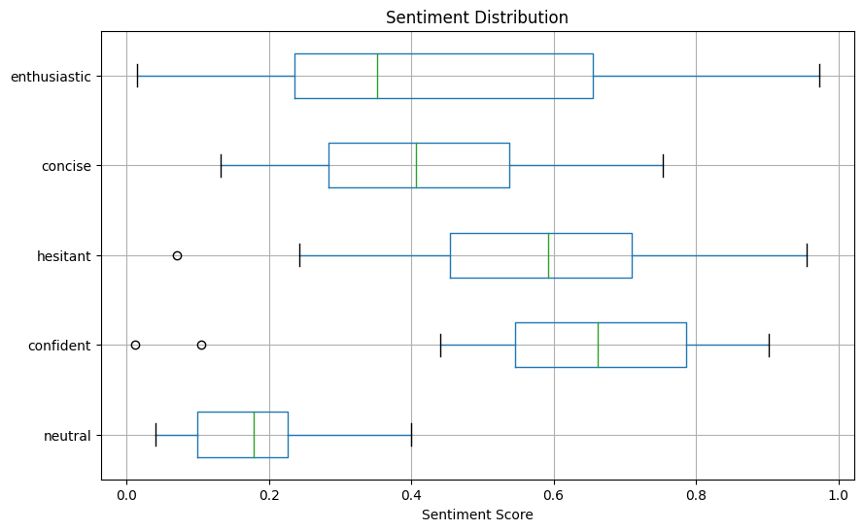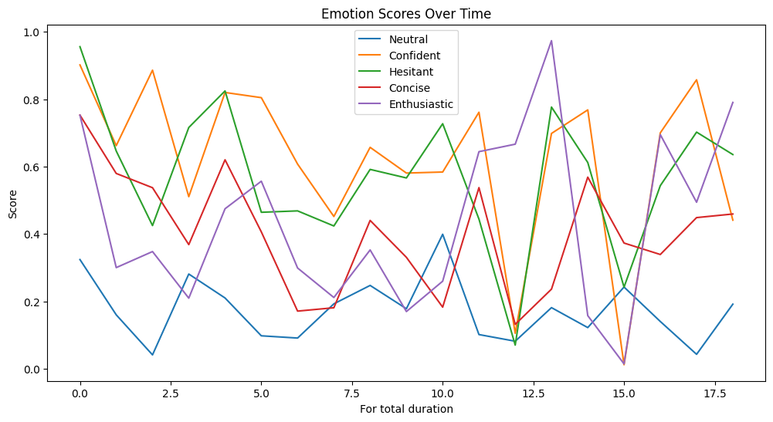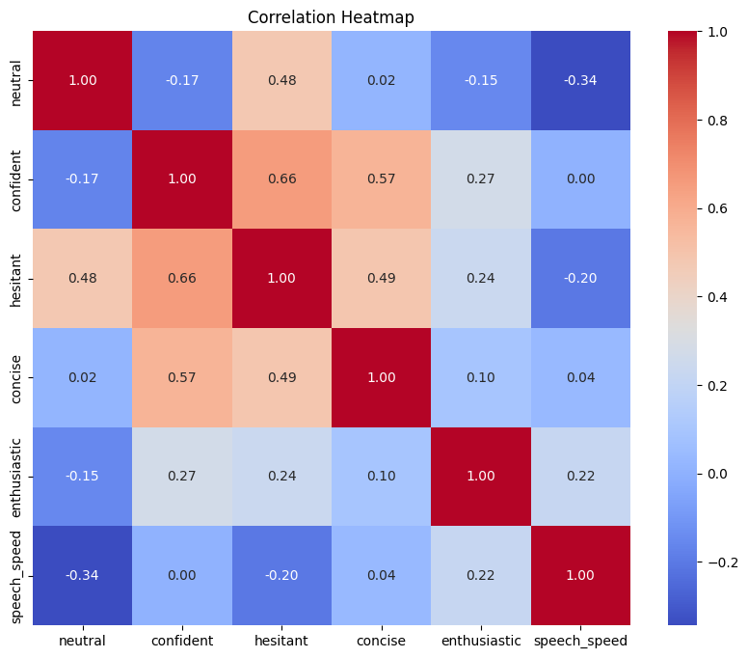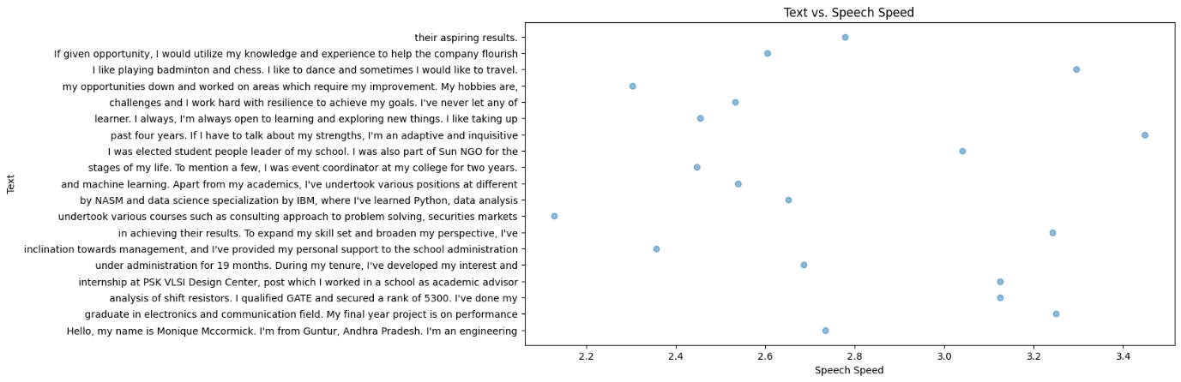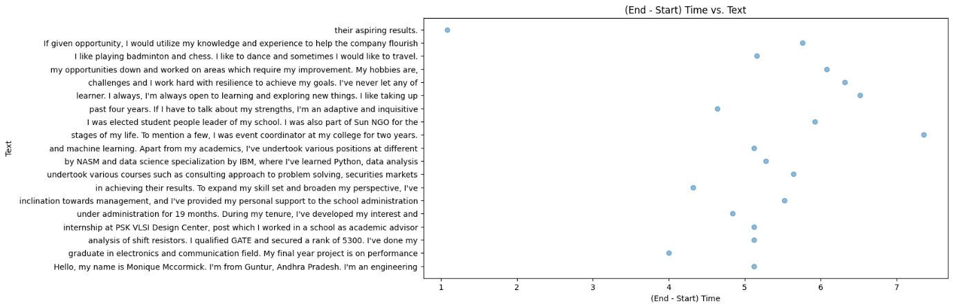

# **CANDIDATE 5:**

## **Analysis of transcripts.txt**

(communication skills)

Sakshi:

Score: 8/10

Remarks: Sakshi provides a good overview of her academic background and certifications. Her mention of winning an international art competition demonstrates a commitment to achieving goals. She could elaborate more on her goals related to using AI for neurodevelopmental disorders.

Areas of Expertise: Mass media, advertising, entrepreneurship, art (drawing and painting), singing, writing, mental health awareness.

## **Graphs of emotion.csv**

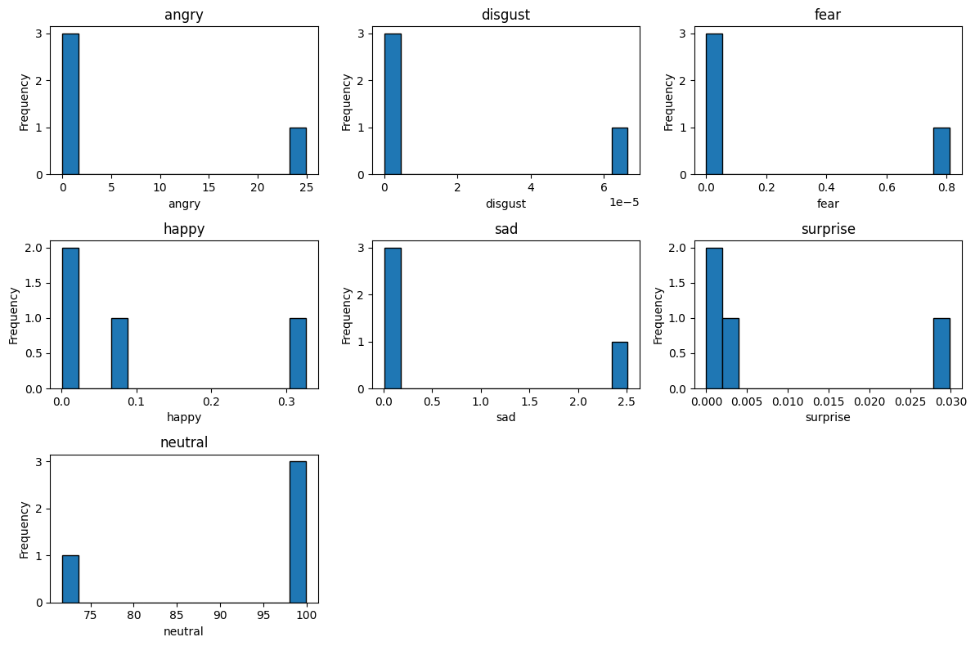

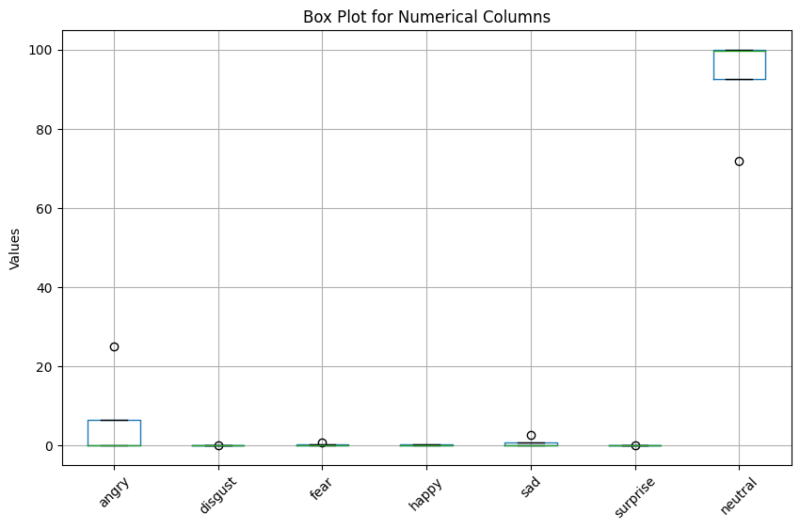

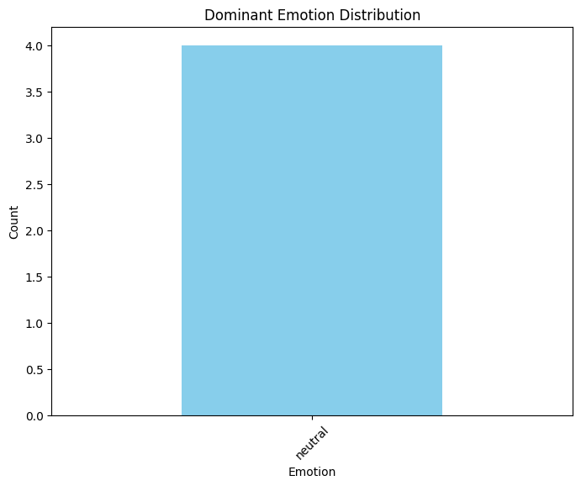

## **Graphs of transcripts_data:**

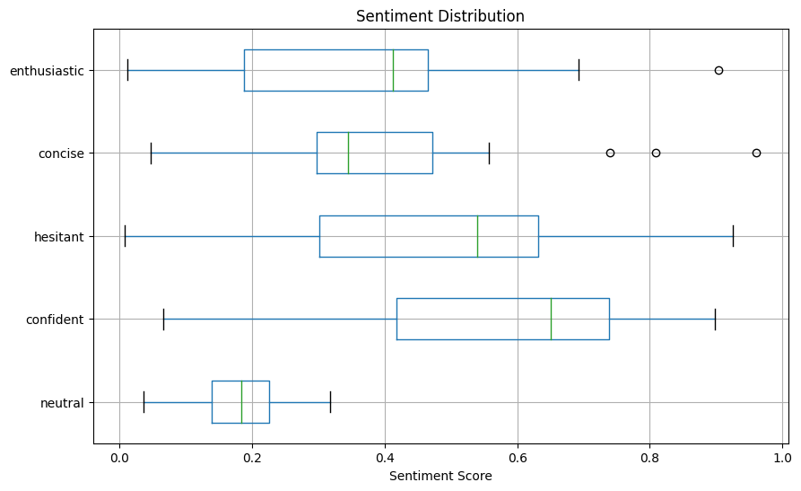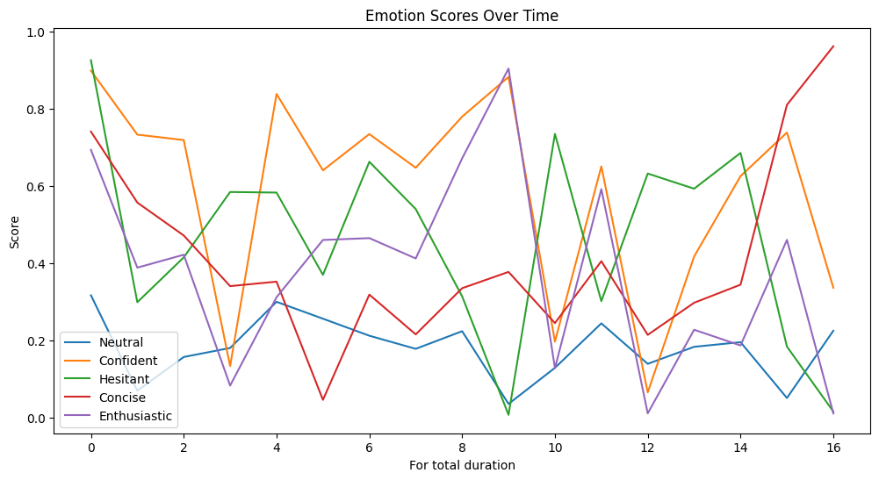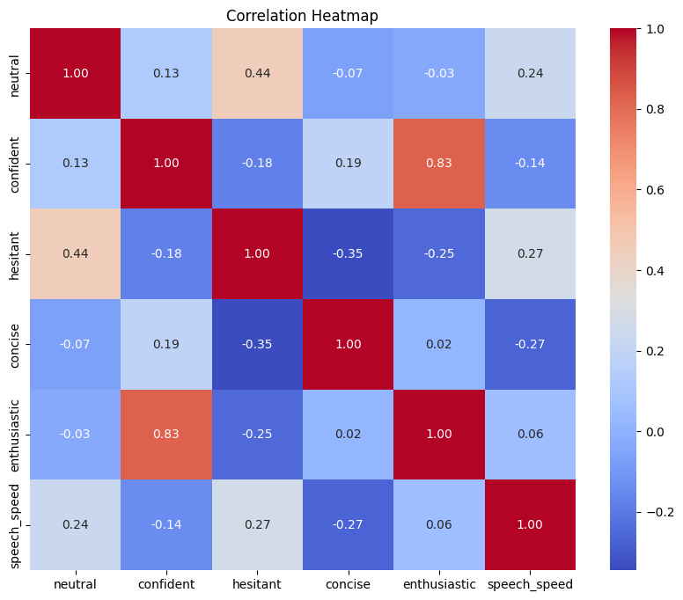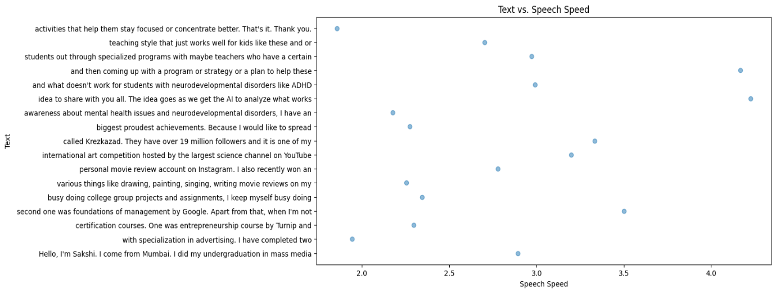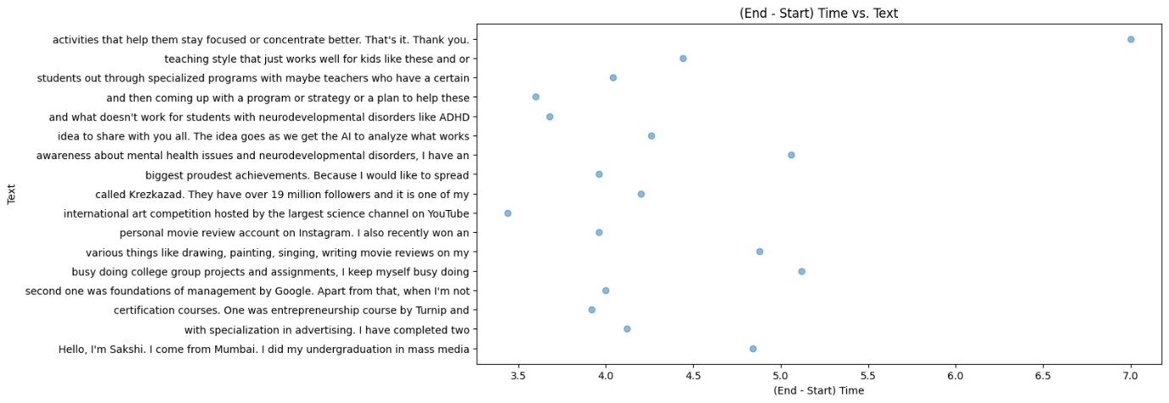

# **CANDIDATE 6:**

## **Analysis of transcripts.txt**

(communication skills)

Nathan Lewis:

Score: 8/10

Remarks: Nathan effectively communicates his transition from consulting to pursuing an MBA in analytics. He mentions his desire for exploration and highlights his involvement in college committees. His enthusiasm for setting and achieving targets is evident.

Areas of Expertise: Consulting, validation processes, software for pharmaceutical clients, media and public relations, social media management, and content writing.

## **Graphs of emotion.csv**

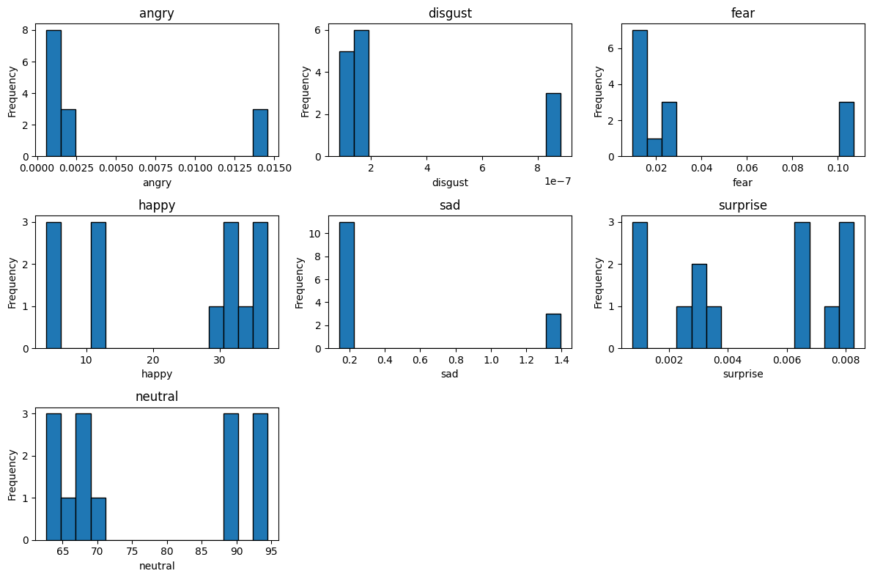

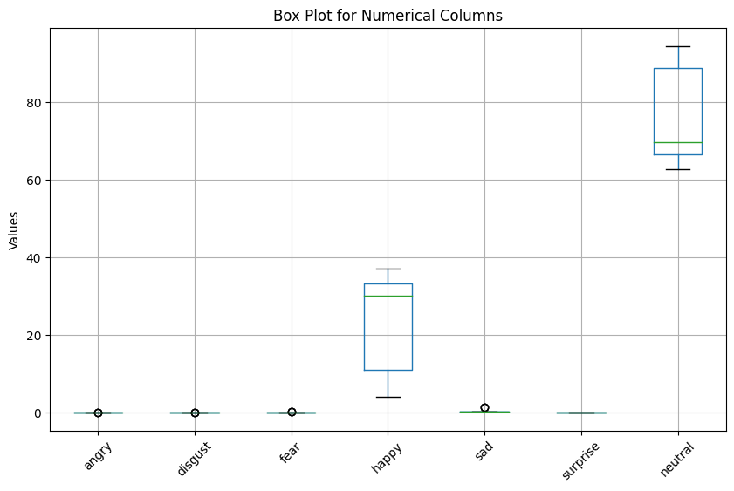

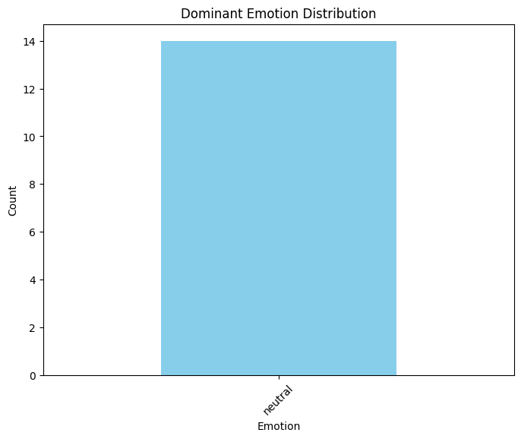

## **Graphs of transcripts_data:**

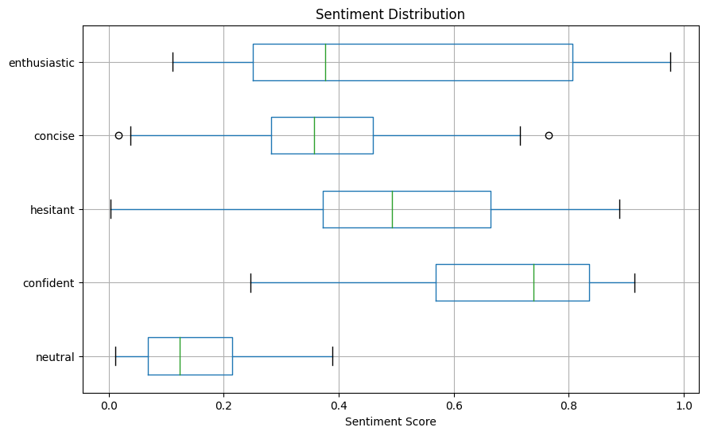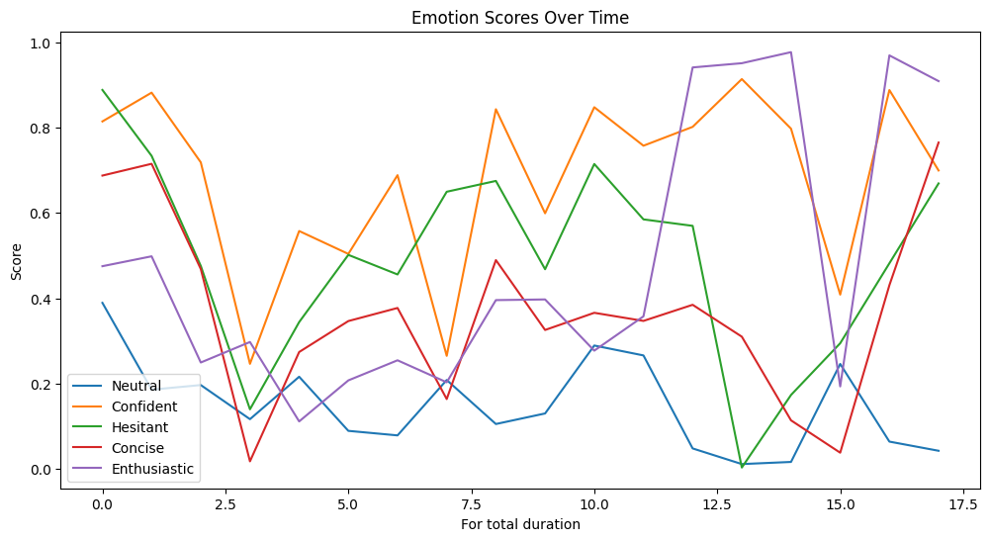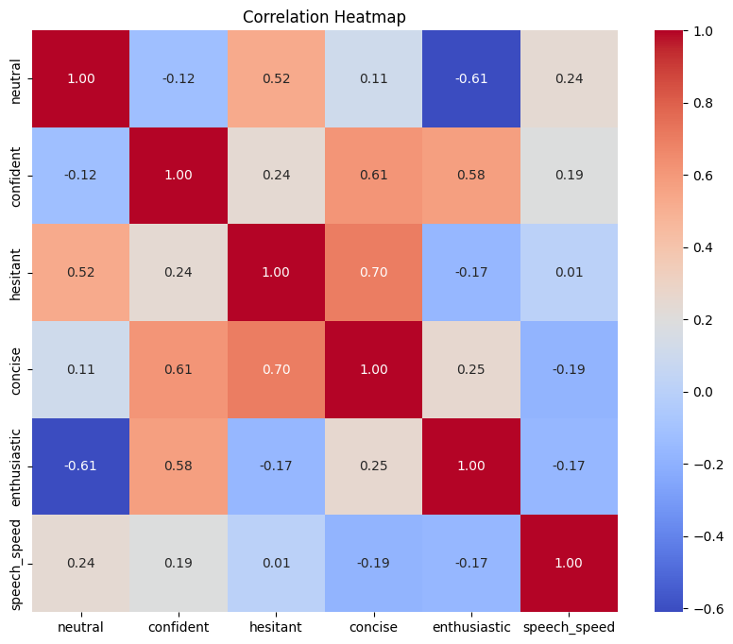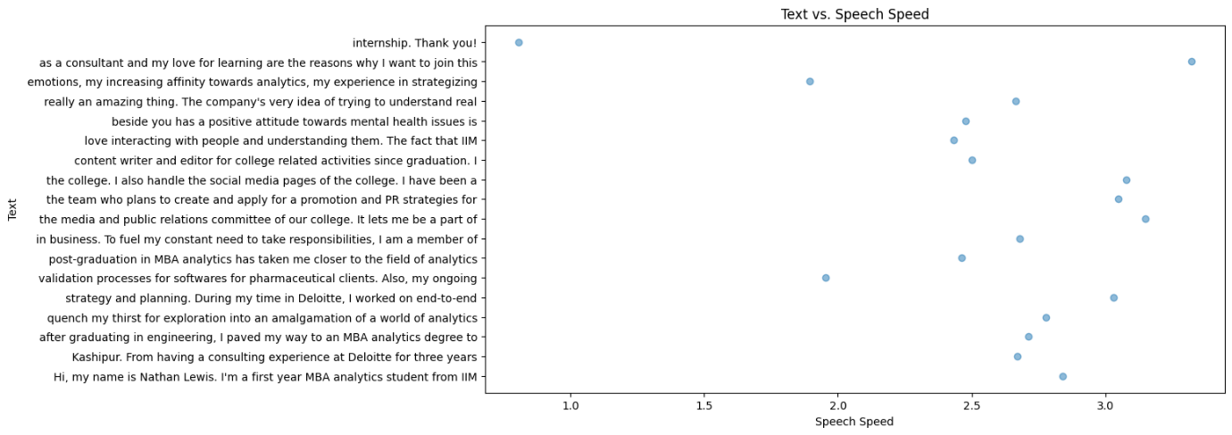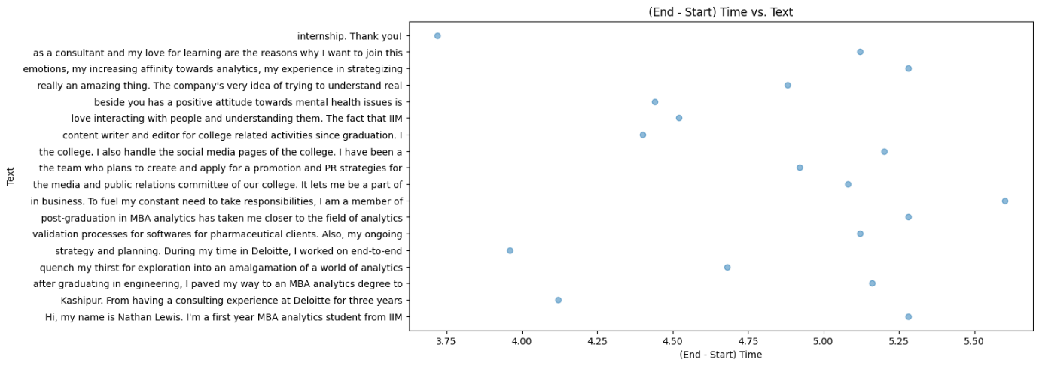

# **CANDIDATE 7:**

## Analysis of transcripts.txt

(communication skills)

Joseph Nichols:

Score: 7/10

Remarks: Joseph shares his educational and work background and expresses a desire for new experiences. While he mentions setting targets, his response could benefit from more specific examples of goal achievements.

Areas of Expertise: Earth science, reinsurance, analytical skills, market understanding, adaptability to new experiences.

## **Graphs of emotion.csv**

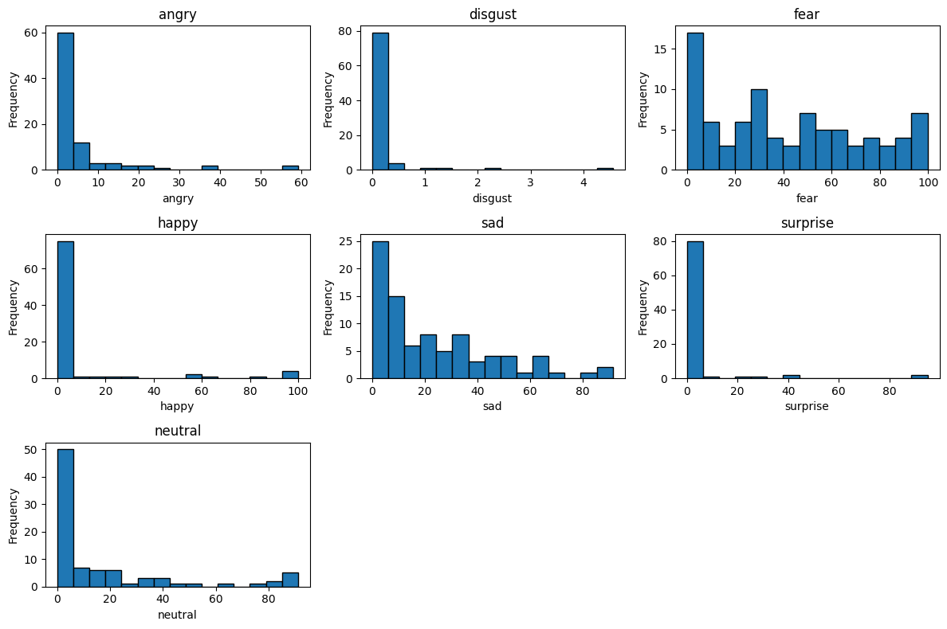

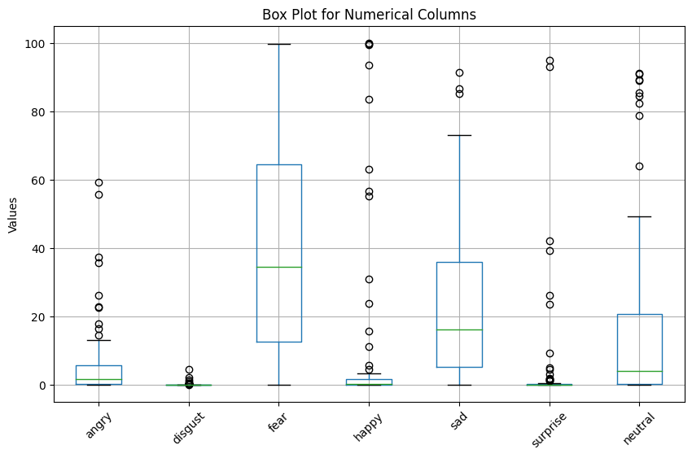

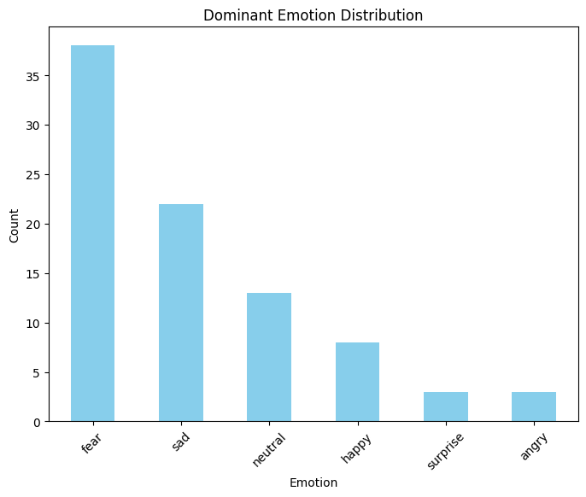

## **Graphs of transcripts_data:**

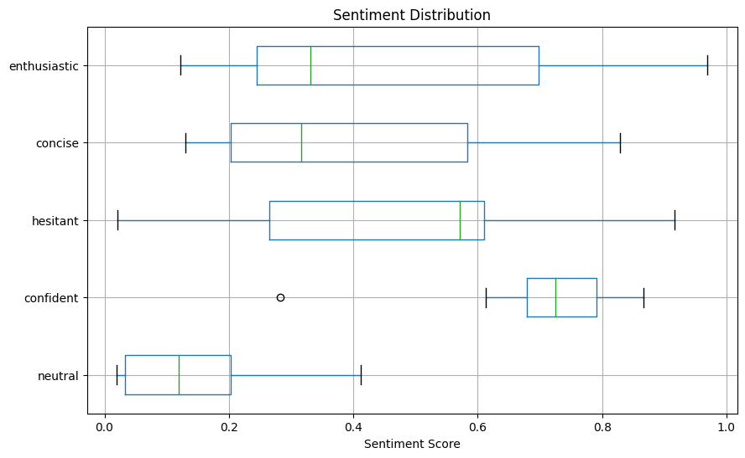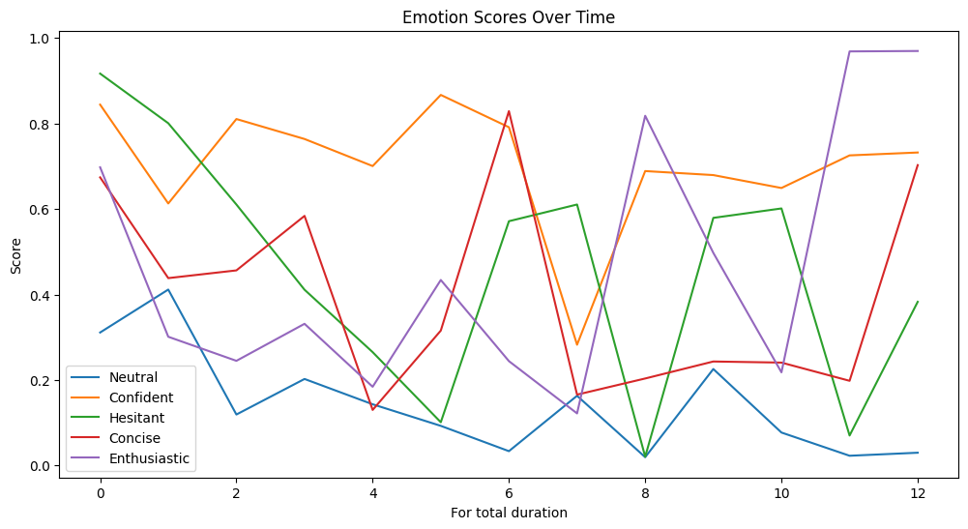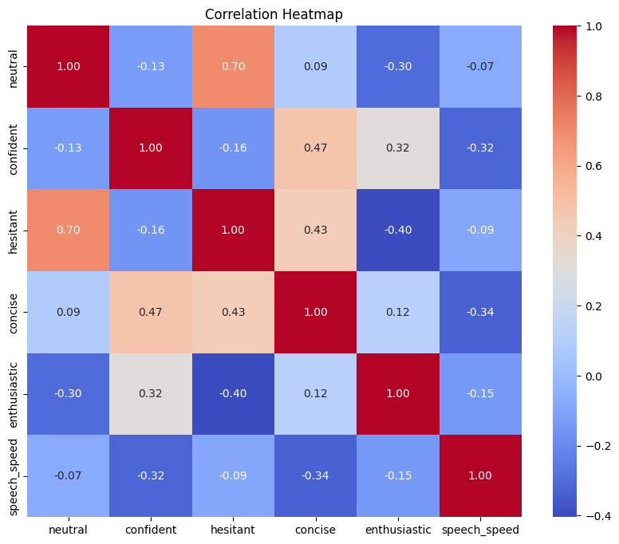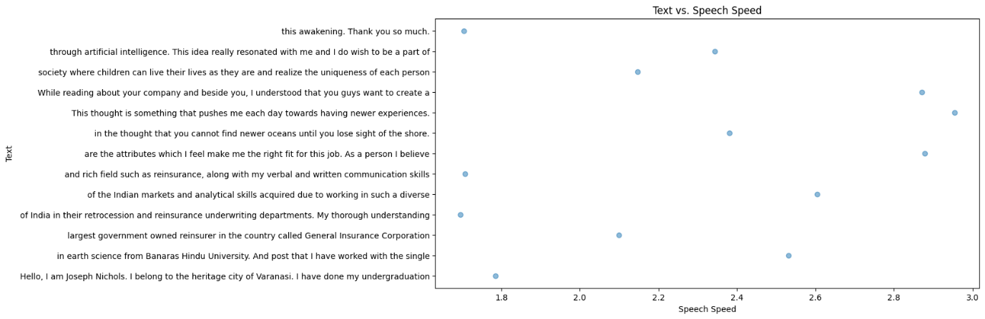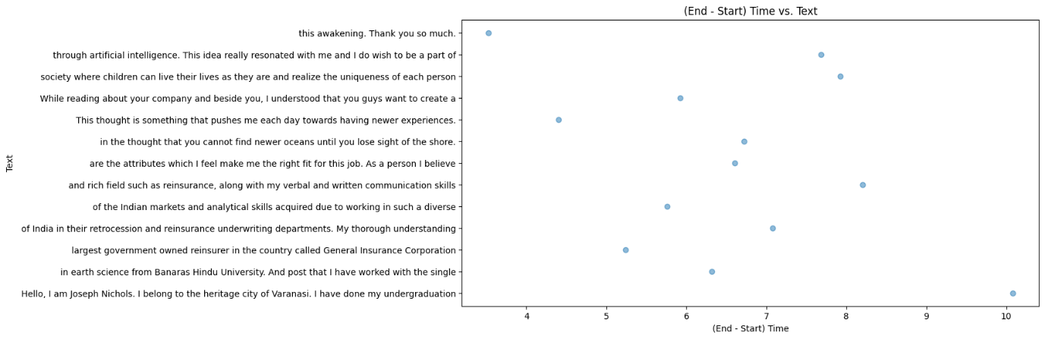

# **CANDIDATE 8:**

## **Analysis of transcripts.txt**

(communication skills)

Srivats Biyani:

Score: 8/10

Remarks: Srivats provides a clear overview of his educational and professional journey. He expresses a strong interest in education and setting bigger targets. He could elaborate further on his approach to achieving these targets.

Areas of Expertise: Chartered accountancy, CFA, internal audit, financial analysis, edtech, finance, data analysis.

## **Graphs of emotion.csv**

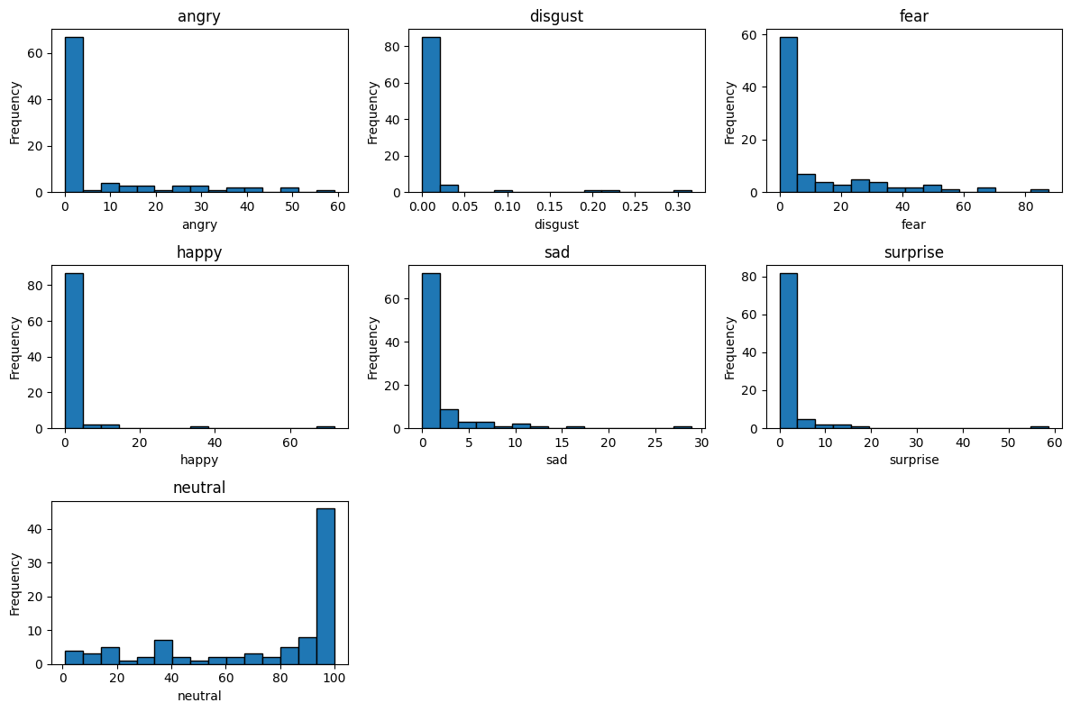

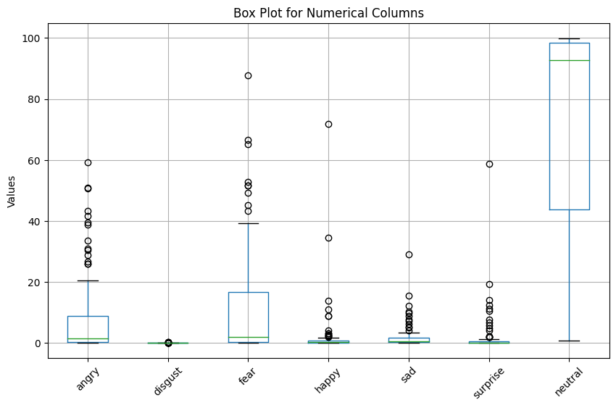

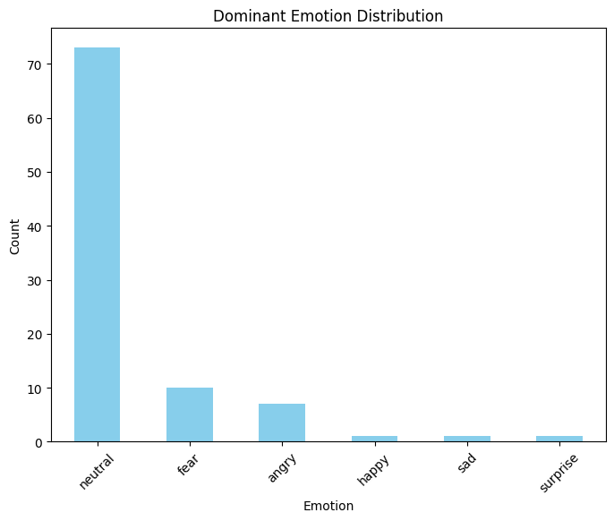

## **Graphs of transcripts_data:**

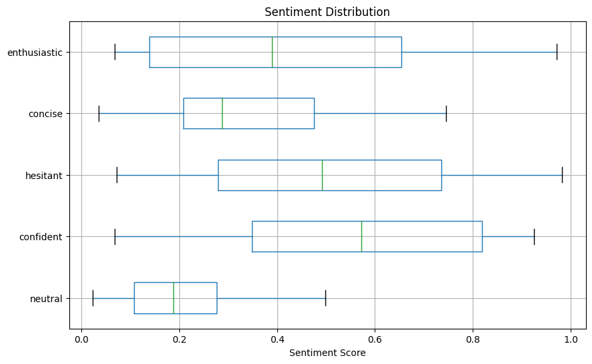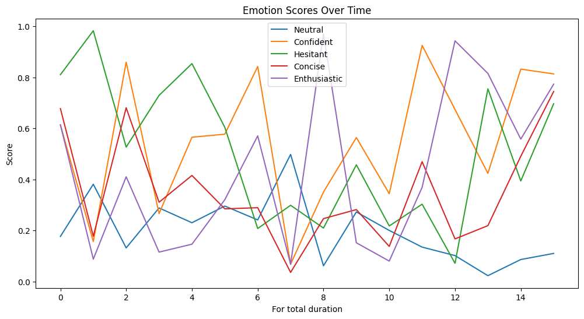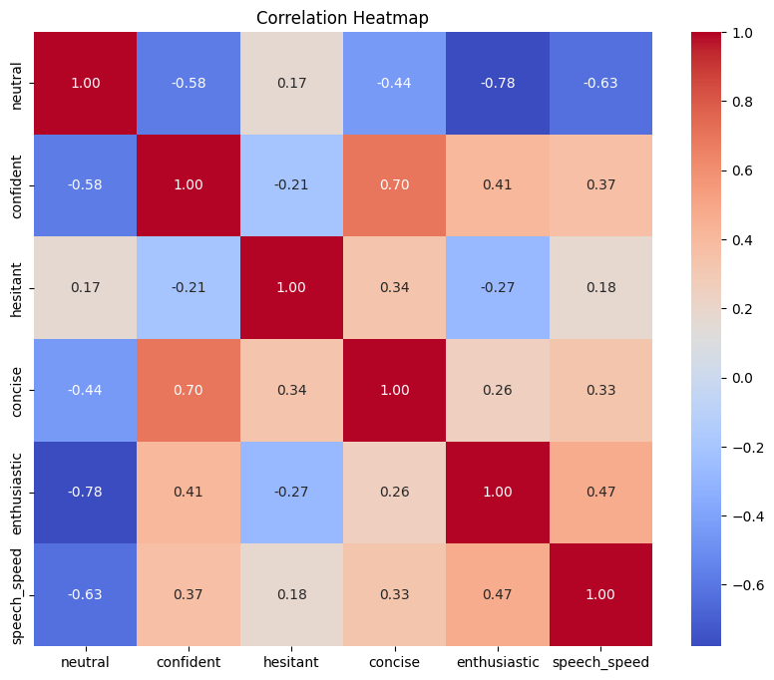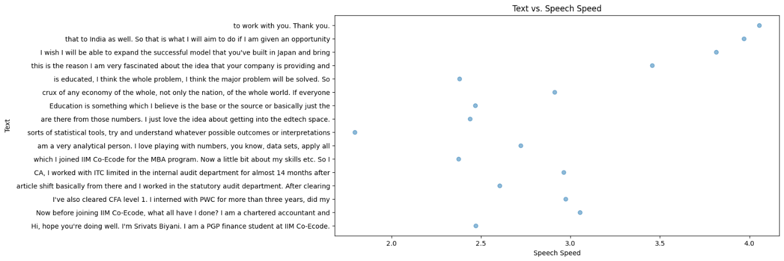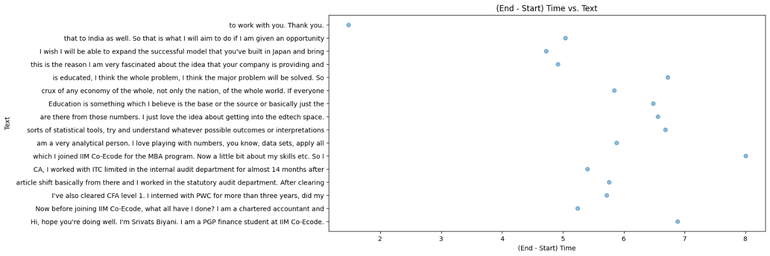

# **CANDIDATE 9:**

## **Analysis of transcripts.txt**

(communication skills)

Alexander Smith:

Score: 10/10

Remarks: Alexander effectively communicates his background and passion for entrepreneurship and AI. He links his experiences to the role's focus on AI and facial expression analysis. His commitment to setting and achieving bigger targets aligns with the company's mission.

Areas of Expertise: Agriculture engineering, entrepreneurship, agritech startups, remote sensing, IoT, artificial intelligence, business development, strategy.

## **Graphs of emotion.csv**

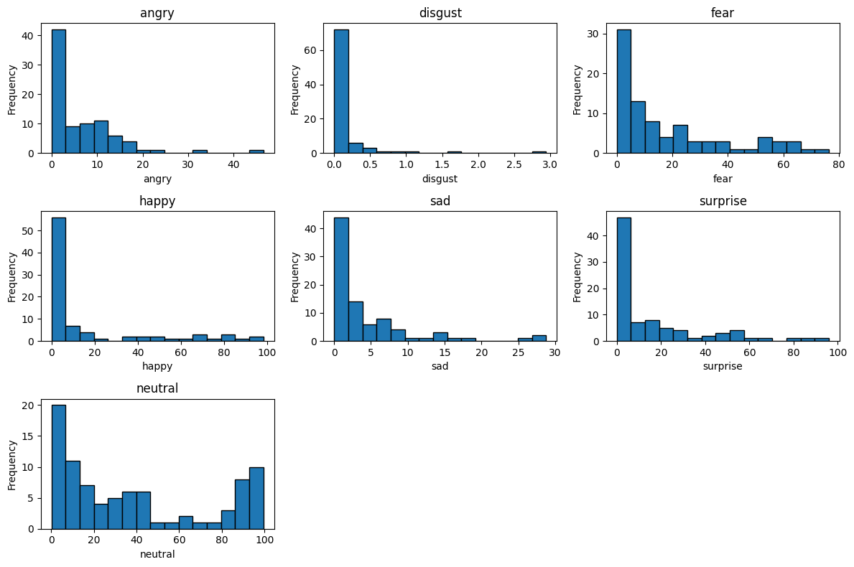

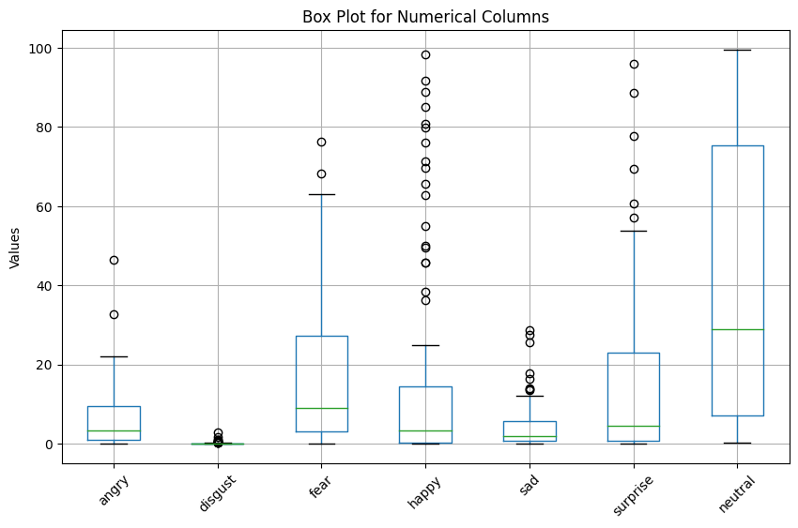

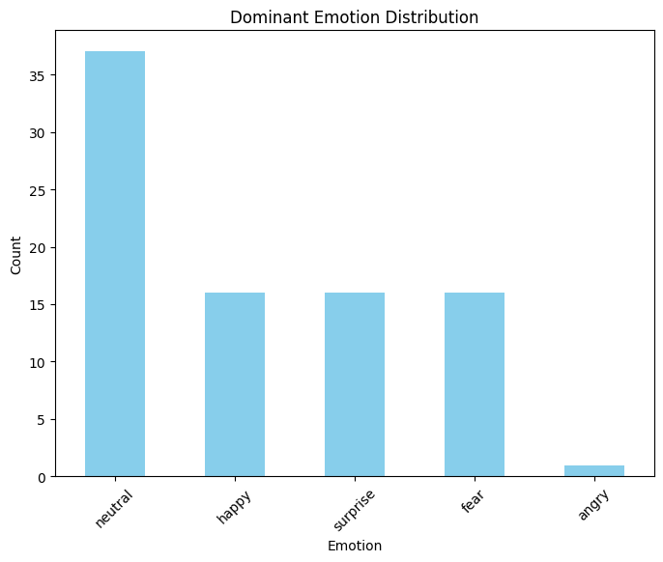

## **Graphs of transcripts_data:**

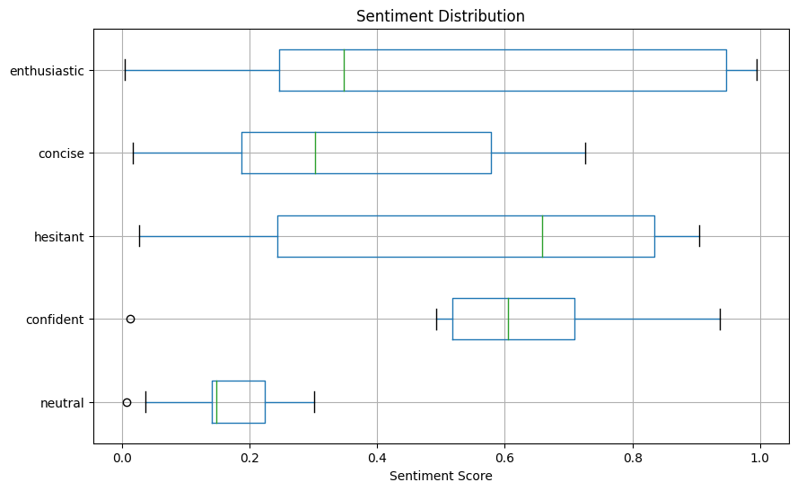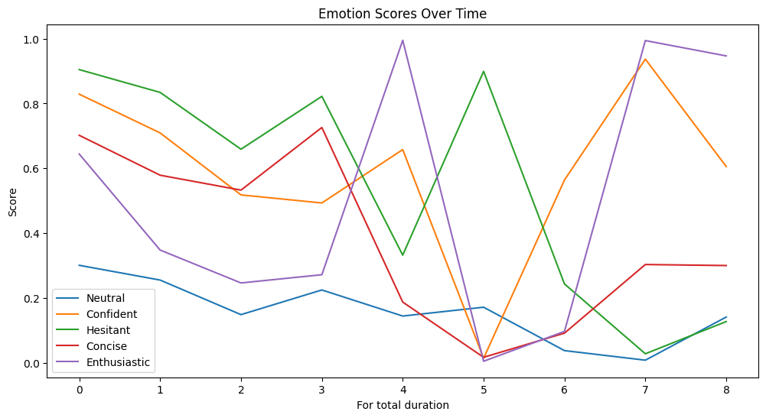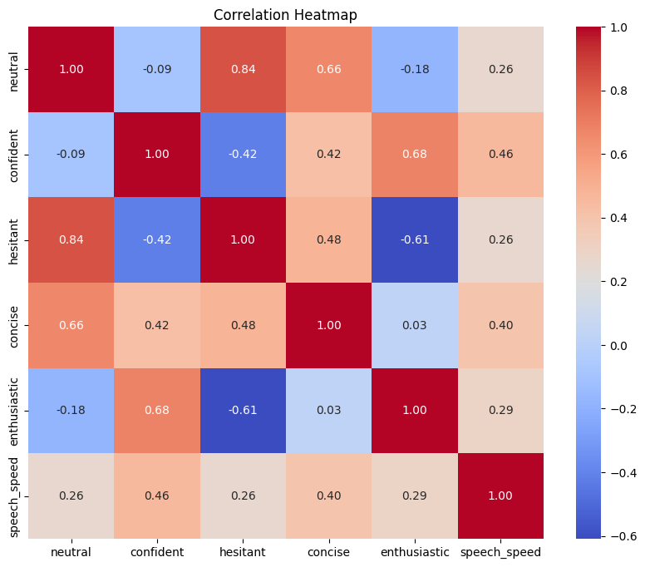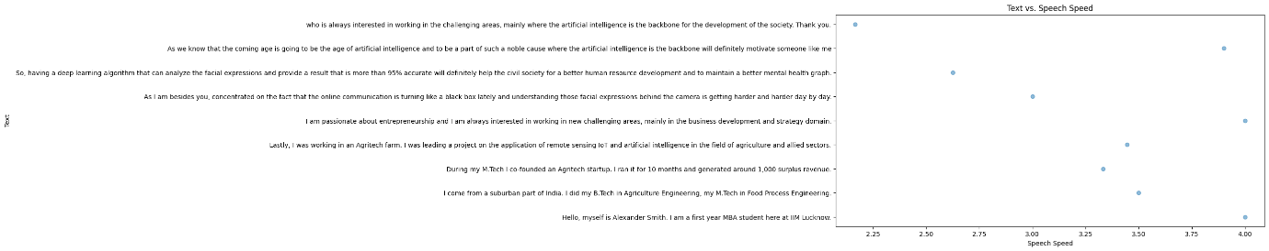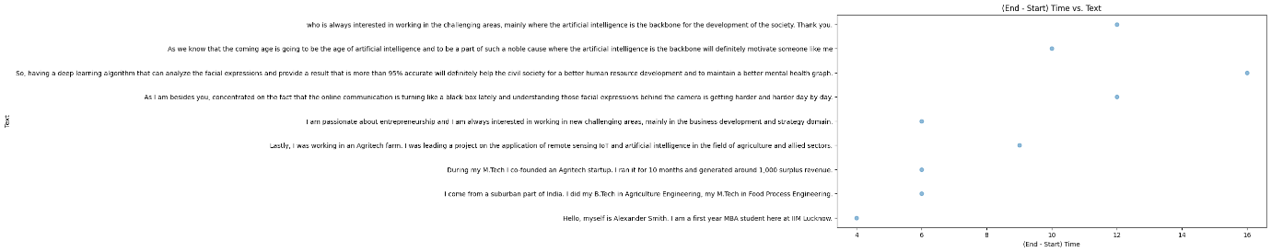

# **CANDIDATE 10:**

## **Analysis of transcripts.txt**

(communication skills)

Michael Ramos:

Score: 8/10

Remarks: Michael Ramos presents a well-rounded profile, highlighting his educational background in Commerce and his internship experience in accounting and taxation.

Areas of Expertise: Commerce, accounting, taxation, leadership (students committee, class representative), extracurricular activities (Bad Scouts and Guide), reading, goal setting.

## **Graphs of emotion.csv**

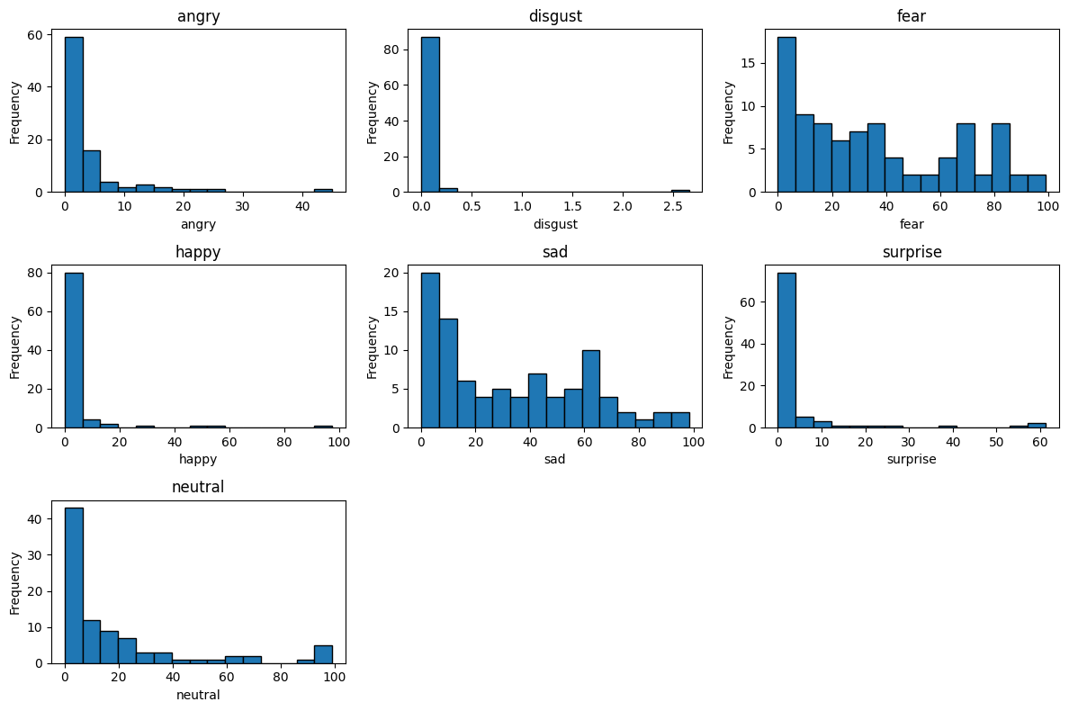

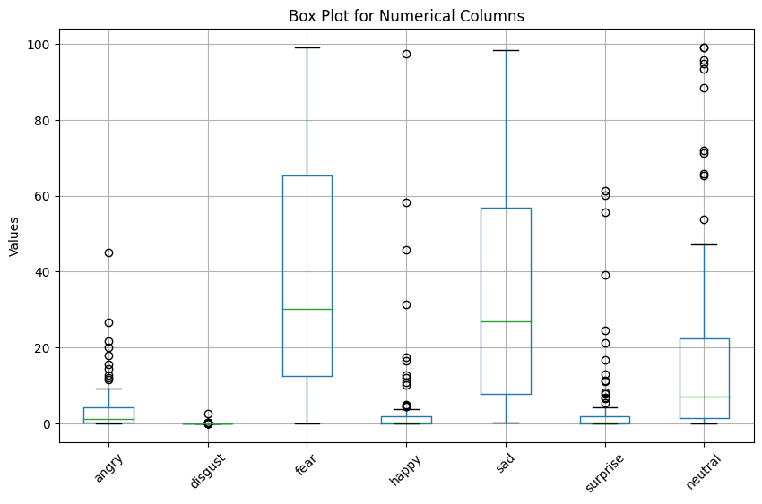

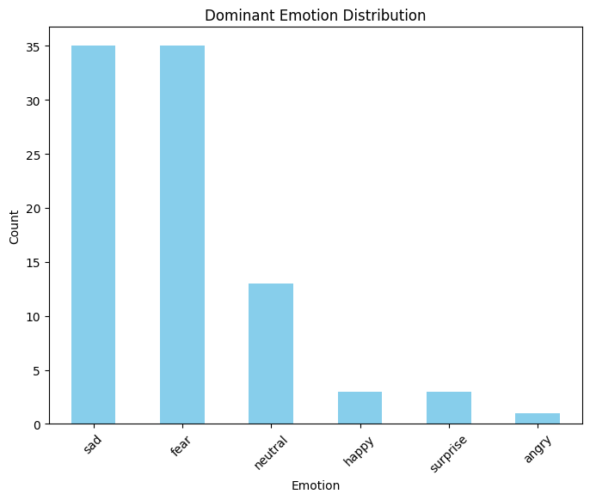

## **Analysis of transcripts_data:**

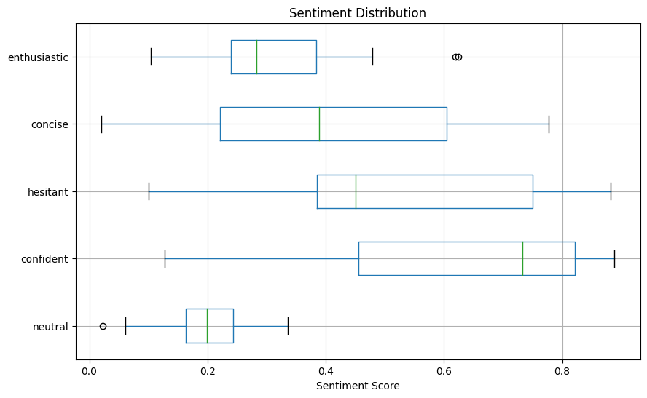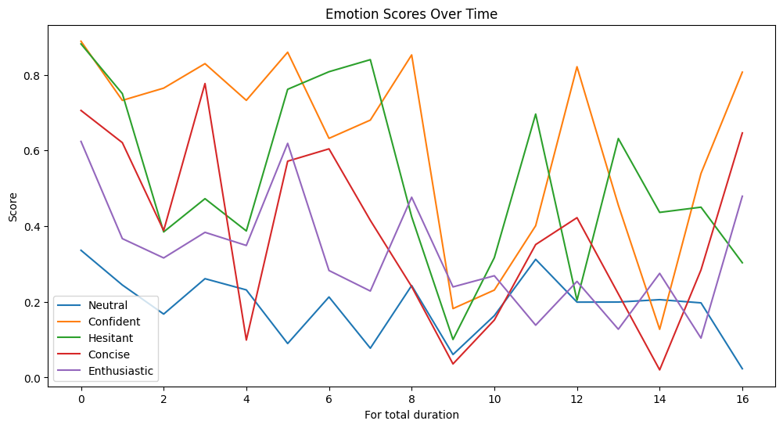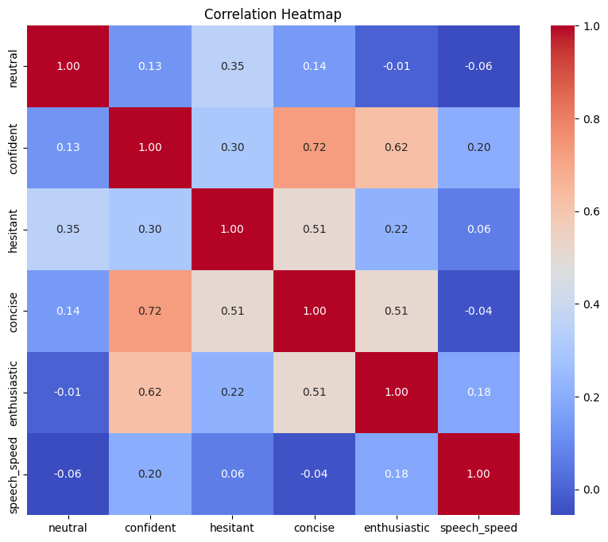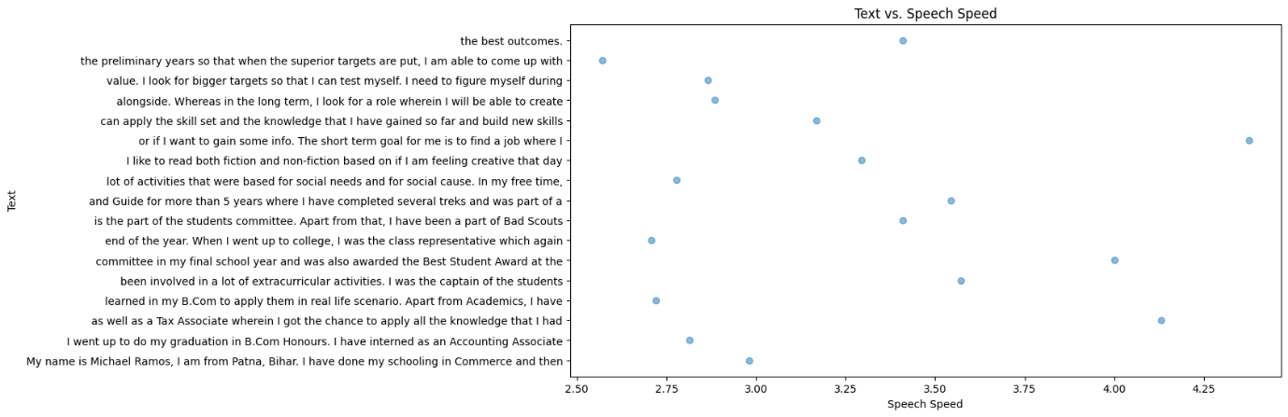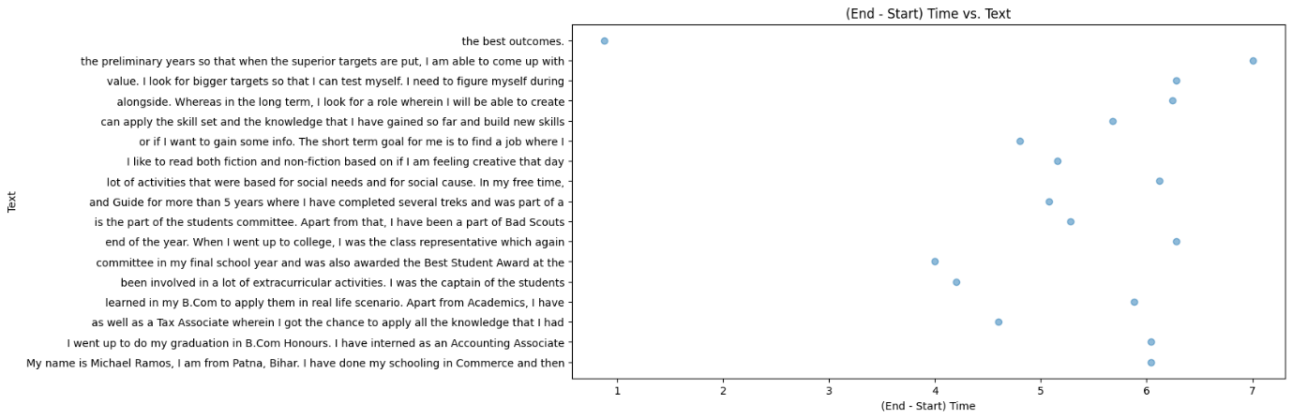

*********THANK YOU **********